Project Design Phase-II
Data Flow Diagram & User Stories

Date | 30 September 2026
Team ID | SWTID-2026-7062
Project Name | AL BLOG NEST
Maximum Marks | 4 Marks

Data Flow Diagrams:
A Data Flow Diagram (DFD) is a traditional visual representation of the information flows within a system. A neat and clear DFD can depict the right amount of the system requirement graphically. It shows how data enters and leaves the system, what changes the information, and where data is stored.
Example: DFD Level 0 (Industry Standard)
Example: (Simplified)



AL BLOG NEST – Data Flow Diagram (Level 1):
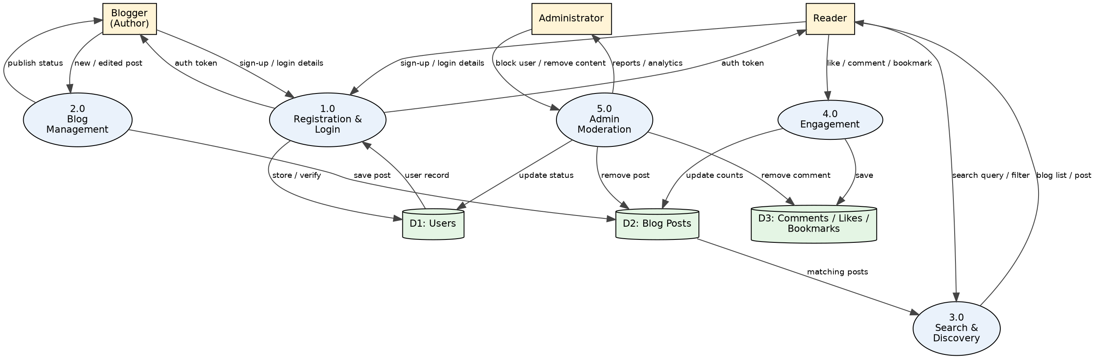

User Stories
Use the below template to list all the user stories for the product.
User Type | Functional Requirement (Epic) | User Story Number | User Story / Task | Acceptance criteria | Priority | Release
Blogger (Author) | Registration | USN-1 | As a user, I can register for the application by entering my email, password, and confirming my password. | I can register and access my account / dashboard | High | Sprint-1
Blogger (Author) | Registration | USN-2 | As a user, I will receive a confirmation email once I have registered for the application. | I can receive the confirmation email and click confirm | High | Sprint-1
Blogger (Author) | Registration | USN-3 | As a user, I can register for the application through Gmail. | I can register and access the dashboard with Google login | Medium | Sprint-1
Blogger (Author) | Login | USN-4 | As a user, I can log into the application by entering email & password. | I can log in with valid credentials and see an error for invalid ones | High | Sprint-1
Blogger (Author) | Login | USN-5 | As a user, I can reset my password if I forget it. | I receive a reset link by email and can set a new password | Medium | Sprint-1
Blogger (Author) | Login | USN-6 | As a user, I can log out and my session is kept secure using a token (JWT). | After logout I cannot open protected pages | High | Sprint-1
Blogger (Author) | Dashboard | USN-7 | As a user, I can view my personal dashboard after login. | Dashboard shows my profile and my blogs | High | Sprint-1
Blogger (Author) | Dashboard | USN-8 | As a user, I can edit my profile (name, bio and photo). | Updated profile details are saved and displayed | Medium | Sprint-1
Blogger (Author) | Dashboard | USN-9 | As a user, I can use the application comfortably on mobile and desktop (responsive UI). | Pages adjust properly to mobile and desktop screens | Medium | Sprint-1
Blogger (Author) | Blog Management | USN-10 | As a blogger, I can create a blog post using a rich text editor. | I can format text and the post is saved | High | Sprint-2
Blogger (Author) | Blog Management | USN-11 | As a blogger, I can upload a cover image for my blog. | Image is uploaded and shown with the post | Medium | Sprint-2
Blogger (Author) | Blog Management | USN-12 | As a blogger, I can save my blog as a draft and publish it later. | Draft is visible only to me until I publish | High | Sprint-2
Blogger (Author) | Blog Management | USN-13 | As a blogger, I can add a category and tags to my blog. | Post appears under the selected category and tags | High | Sprint-2
Blogger (Author) | Blog Management | USN-14 | As a blogger, I can edit my published blog. | Changes are saved and visible to readers | High | Sprint-2
Blogger (Author) | Blog Management | USN-15 | As a blogger, I can delete my blog. | Blog is removed after I confirm deletion | Medium | Sprint-2
Blogger (Author) | Blog Management | USN-16 | As a blogger, I can view all my blogs with their status on my dashboard. | List shows published and draft blogs | Medium | Sprint-2
Reader | Blog Discovery | USN-17 | As a reader, I can view the latest blogs on the home page. | Latest published blogs are listed with pagination | High | Sprint-3
Reader | Blog Discovery | USN-18 | As a reader, I can open and read a full blog post. | Full post with author and date is displayed | High | Sprint-3
Reader | Blog Discovery | USN-19 | As a reader, I can search blogs by title, keyword or author. | Matching blogs are shown for my search | High | Sprint-3
Reader | Blog Discovery | USN-20 | As a reader, I can filter blogs by category and tag. | Only blogs of the selected category / tag are shown | Medium | Sprint-3
Reader | Engagement | USN-21 | As a reader, I can like a blog. | Like count increases by one and only once per user | Medium | Sprint-3
Reader | Engagement | USN-22 | As a reader, I can comment on a blog. | My comment appears under the blog | High | Sprint-3
Reader | Engagement | USN-23 | As a reader, I can bookmark blogs to read later. | Blog appears in my bookmarks list | Low | Sprint-3
Reader | Engagement | USN-27 | As a reader, I can follow my favourite authors. | Author appears in my following list | Low | Sprint-4
Reader | Engagement | USN-28 | As a reader, I can share a blog through social media links. | Share link opens with the blog URL | Low | Sprint-4
Administrator | Admin Management | USN-24 | As an administrator, I can view, block and unblock users. | Blocked user cannot log in | High | Sprint-4
Administrator | Admin Management | USN-25 | As an administrator, I can moderate and remove inappropriate blogs and comments. | Removed content is no longer visible to readers | High | Sprint-4
Administrator | Admin Management | USN-26 | As an administrator, I can view platform analytics (users, posts, activity). | Dashboard shows total users, posts and comments | Medium | Sprint-4

